EZZYSAVE Landing Page Ideas Check out bankgreenwood.com

Join EzzySave Now. Secure your financial future

Sign up for our wait list to become a part of EzzySave.

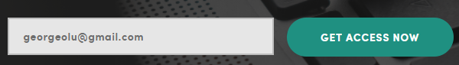

When a customer put their email the following page is loaded

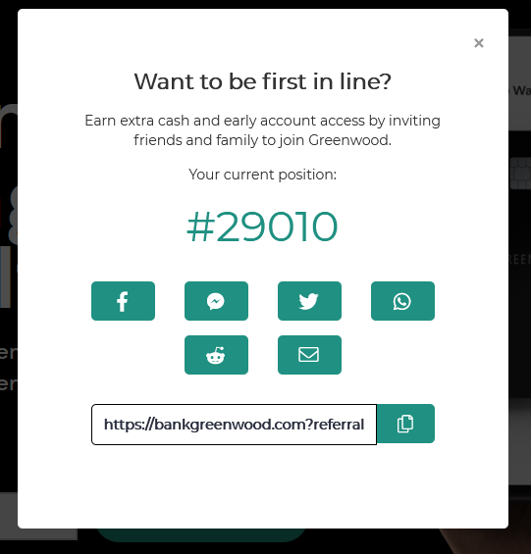

EZZYSAVE powered by Geefto

**Home:** EzzySave is the signature service of Geefto Corporation. Geefto has created the EzzySave app to encourage you to save toward specific goals such as savings for the future, college, start a business or down payment for your own home.

When you join our savings program, you will join our automatic reward program and Geefto Corporation will match your reward and match your saving goals.

For example, if your goal is to save a $1,200.00 over a year, Geefto will match you with our partner that will match your savings so that at the end of your savings plan, you will be given $2,400.00

**Why Us**: Geefto Corporation is a social enterprising bank and we believe in financial inclusion of everyone. Through the EzzySave app we will provide you with the tools to manage your money. We share our revenue with you which will enable our customers to reach their savings goals faster.

**Features:**

**Savings Account**

Commit to a savings plan and we will connect you with our partners who will match your saving goal. EzzySave plan allows our customers to save toward specific goals. Through our reward program customers reward are added back to the savings account of our customers.

### Checking Account (Include Debit/Prepaid Card)

Checking accounts are designed for regular transactions. We offer debit cards for customers to access their checking accounts. By swiping your card enables you to automatically enroll in our revenue sharing program when you use your card to make purchases or withdrawals from ATMs.

### Secured Savings Account with lines of credit

An EzzySave Savings Secured Line of Credit is a revolving line of credit that allows funds to be borrowed, repaid and then borrowed again. The Line of Credit is secured by funds from your geefto savings or money market account.

FAQ

• [What is EzzySave](javascript:void(0))

• [How secure would EzzySave be?](javascript:void(0))

• [What are the savings interest rates?](javascript:void(0))

• [Do you offer free account registration?](javascript:void(0))

• [When would EzzySave launch?](javascript:void(0))